The Birth of Alexander
http://www.getty.edu/education/teachers/classroom_resources/curricula/stories/lesson_plan_index.html
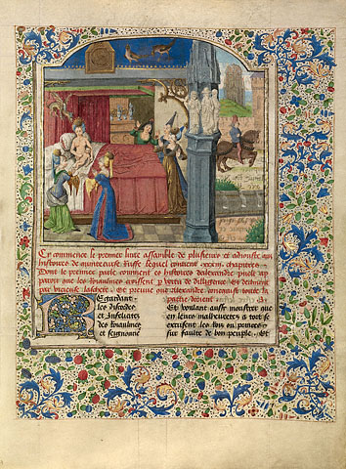
This image is available for download, without charge, under the Getty's Open Content Program.
Attributed to the Master of the Jardin de vertueuse consolation
Flemish, Bruges, about 1470 - 1475
Tempera colors, gold leaf, gold paint, and ink on parchment
17 x 13 in.
MS. LUDWIG XV 8, FOL. 15

The narrative of the exploits of the Macedonian leader Alexander the Great begins with his portentous birth, illustrated in this miniature. In the main scene, his mother Olympias, wife of Philip of Macedon, sits up in bed to hand the newborn infant Alexander to her ladies-in-waiting. Wearing sumptuous garments and elaborate hats, they gesture in excitement. The dragon flying above Olympias's head refers to Alexander's supposed divine origin: According to the Delphic oracle, Olympias conceived Alexander by the god Zeus Ammon disguised as a dragon.

To the right, the illuminator included a later episode: Still a child, Alexander gains mastery over Bucephalus, the sturdy war horse that will take him to his later military victories. By depicting the burning Temple of Diana at Ephesus in the background, the illuminator also referred to Alexander's future defeat of Asia.
The illuminator made the ancient story concrete and accessible by depicting the scene in a fifteenth-century setting. The raised canopy bed with velvet bedspread and hangings, the sideboard with plate and ewers, and the fabrics and fashions of the women's luxuriously detailed dresses all reflect the lavish style of the Burgundian court.

